**Chapter 3**

**System Analysis**

**3.1 Functional Requirements**

The functional requirements of the A.S.C.A.D. can be explained by considering the following features of the system:

**3.1.1 Record details of the patient**

The software must initially input necessary details about the patient such has his/her name, age, name of the medical practitioner etc. These details would later be displayed on the final report as well.

**3.1.2 Input Image**

The system should take as input a high quality microscopic image of the blood smear of the patient in order to perform various computations and analysis on the image and to determine whether the patient is diagnosed with sickle cell anaemia or not.

**3.1.3 Display results**

The system, after performing all the computations and analysis on the input image, must display the results of the patient with the diagnosis and along with the details of the patient taken at the start of the process.

**3.2 Non-functional Requirements**

* + 1. **Performance Requirements**

The system must be able to seamlessly diagnose the disorder in the patient’s blood sample by analyzing the image of the sample. The system must be able to adjust itself appropriately to the different colors and shades of images taken using different cameras and must also be able to input images of different dimensions.

* + 1. **Safety and security requirements**

The access to this system must lie only with authorized pathologists and technicians (in case of the system being used at the pathology lab) or only with the patient (if used personally). This would overcome the risk of having nuisance creators or any other person from making changes to the underlying code of the system. The device on which the software is ported must be kept in a stable environment that is free of any cause of physical damage that can be caused to it.

* + 1. **Software quality attributes**
* **Reliability :**

The system must provide genuine results about the presence of the disorder in the patient, which must be accepted by all pathologists/medical bodies. The results displayed must include accurate information about the presence of sickle shaped cells.

* **Availability :**

This software must be available to the concerned officials/people at all times, whenever needed. The software does not include any login requirements and hence can be used immediately without any authorization if one has access to it. The use and access to this system must be confined by the organization/person by physical means.

* **Maintainability :**

The software would not require any maintenance explicitly. However the hardware over which this software would be installed would require frequent maintenance checks. The only change the software would probably undergo would be in case of any update to the current installed version being released by the proprietors of the software.

* **Portability :**

The software must be able to run on all standard devices across all possible operating systems. The end user must not face any difficulty or must not require any technical assistance in porting the software to another device.

**3.3 System Requirements**

**3.3.1 Hardware Requirements**

For desktop PC, a mid-range specification, good enough to run MATLAB would suffice. Embedded systems will have much lower hardware requirements and would be dependent on features implemented.

A typical desktop PC would optimally run the program with the following specifications.

* ~2.0 Ghz Multi-core Processor or 2.6 Ghz Single core
* 1.5 GB or more RAM
* 2-3 GB of free space
* 128 MB of graphics memory

**3.3.2 Software Requirements**

MATLAB, if present, can directly run this software on any recent Windows, Linux or Macintosh systems. The following versions of operating systems are supported:

* Windows XP, Vista, 7, 8
* Mac OSX v10.7 or more
* Linux Ubuntu 13+, RedHat 6+, Debian 7.x

In case of embedded systems, this algorithm can be automatically translated to C using emlc/codegen, a command-line tool in Real-Time Workshop that generates C code from Embedded MATLAB code. A microcontroller with an appropriate compiler for embedded C could be used to run this.

* 1. **Use case diagram and description**

**3.4.1 Use case diagram**

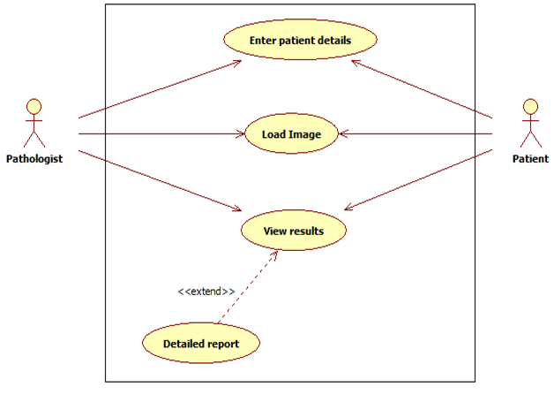

Fig. 3.4.1.1 Use Case Diagram

**3.4.2 Use case description**

|  |  |  |
| --- | --- | --- |
| **Actor** | **Use case** | **Description** |
| Pathologist / Patient | Enter patient details | The actor initially has to feed in the details about the patient such as patient name, contact details, age, name of the medical practitioner etc. |
| Pathologist / Patient | Load image | High quality microscopic image of the blood smear of the patient is fed into the system for further computation and analysis to diagnose the presence of sickle shaped cells in the smear. |

|  |  |  |
| --- | --- | --- |
| Pathologist / Patient | View results | On completion of the analysis carried out by the software on the input image, the result is displayed to the actors. |
|  | Detailed report | On completion of the analysis carried out by the software on the input image, a detailed report of the analysis will be displayed to the actors |

Table 3.4.2.1 Use Case Description